**DATE-15/03/2024**

**ELECTIVE MODULE -3**

**REGISTRATION NO - ADIT22AP02849**

**NAME - ROSHNI VERMA**

**HARDWARE/SOFTWARE:**

1.COMPUTER/LAPTOP

2.WINDOWS 10/11

3.GOOGLE CROOM/ MICROSOFT EDGH

4. INTERNET

5.ANGULAR

6.NODE

7.MONGODB COMPASS

**QUESTION- 1**

Step-1 Angular install and visual studio.

Step -2 CREATE a folder in c drive.

Step-3 visual studio open then folder open.

Step-4Terminal open and code are execute, and install .,app.component.html and welcome page are created and code are putted.

cd welcome-to-adit

ng new welcome-to-adit

npm install -g @angular/cli

ng build

Ng serve

Step-5 then run ng serve and output is coming in browser.

.

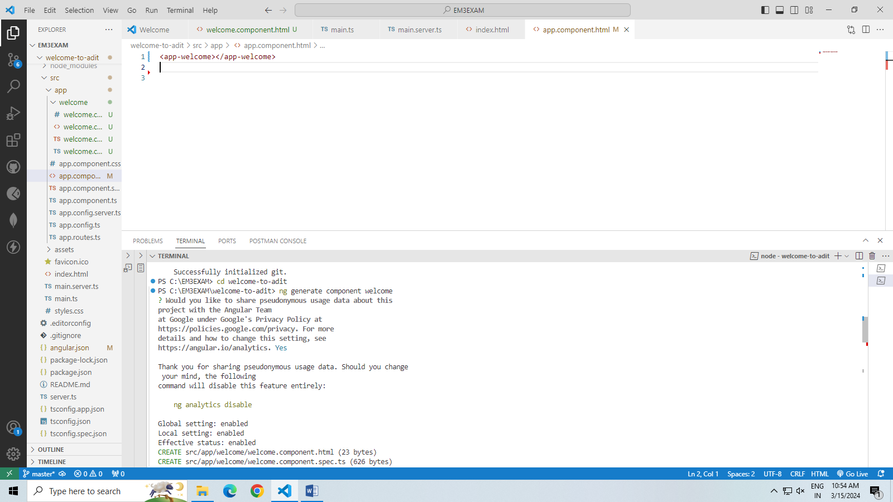

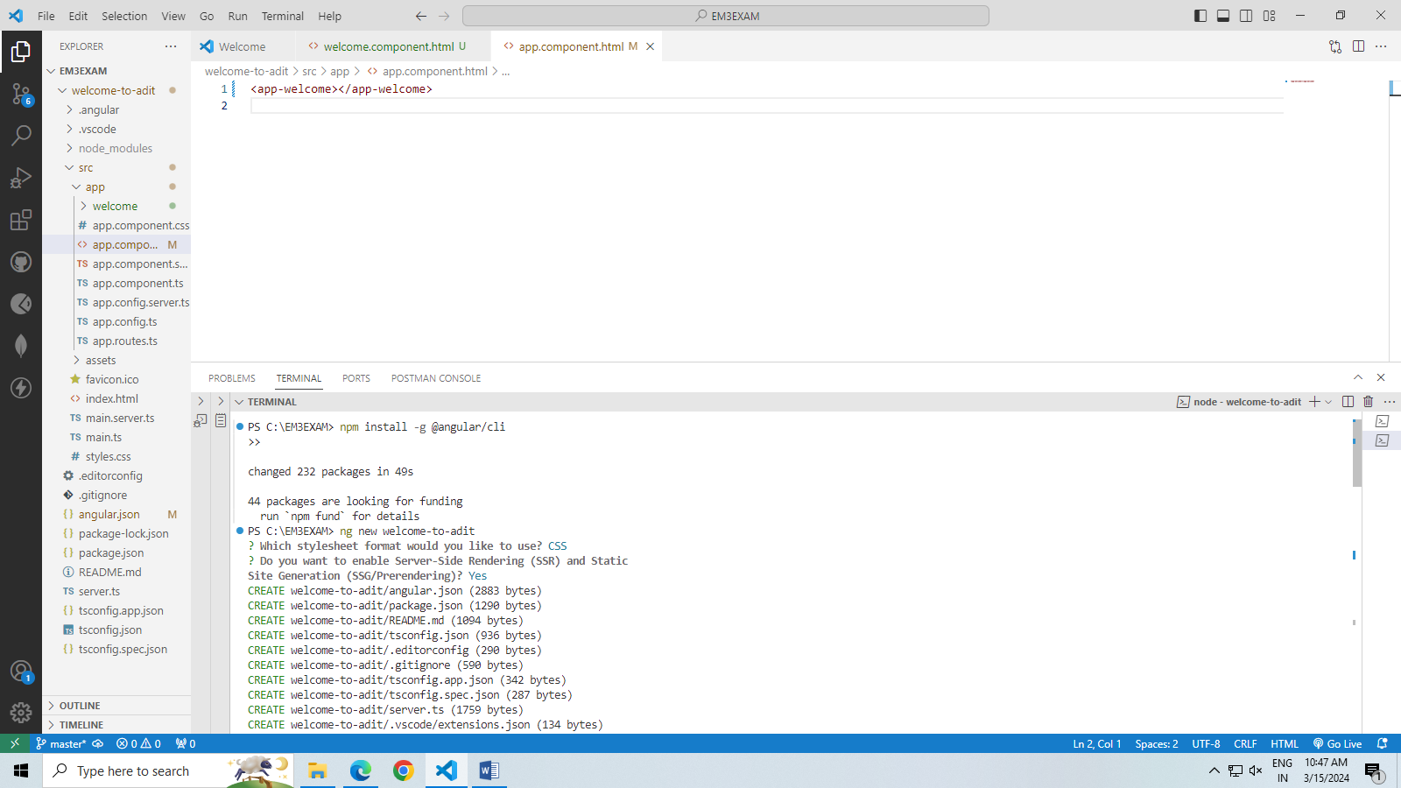

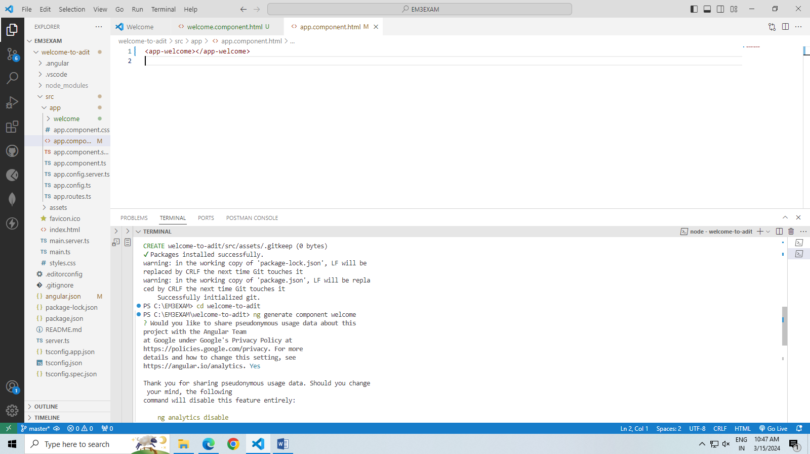

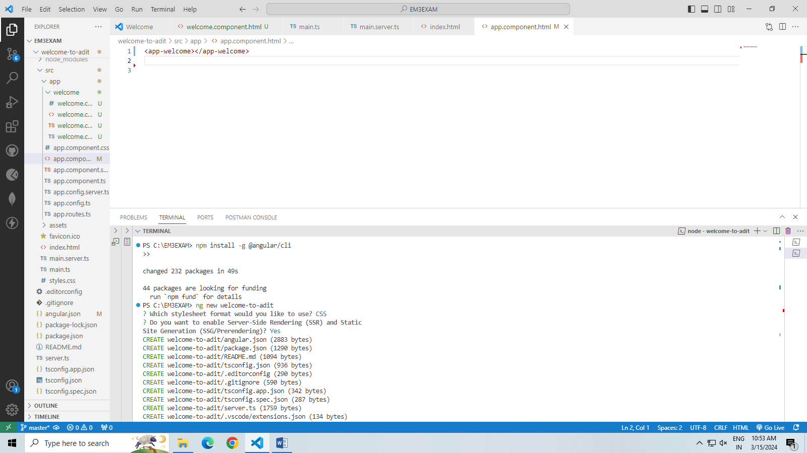

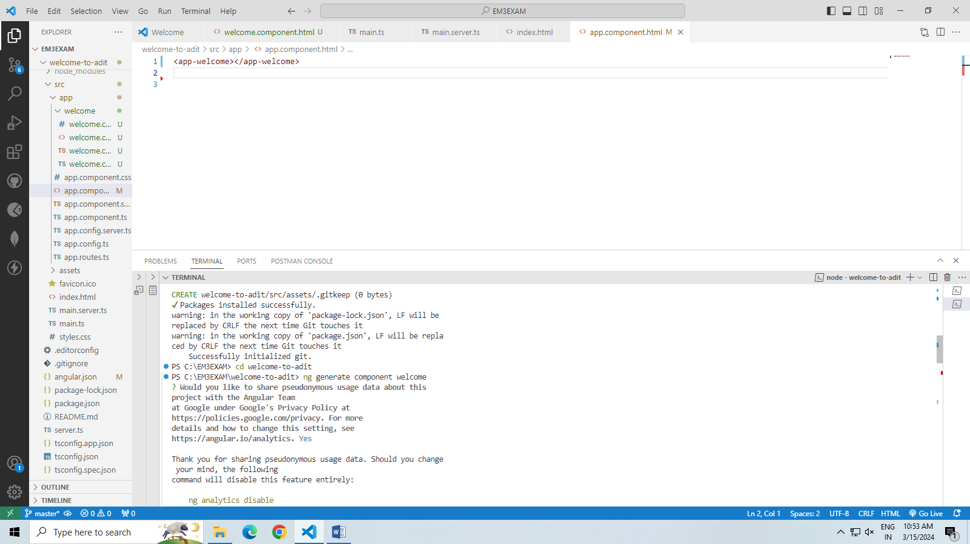



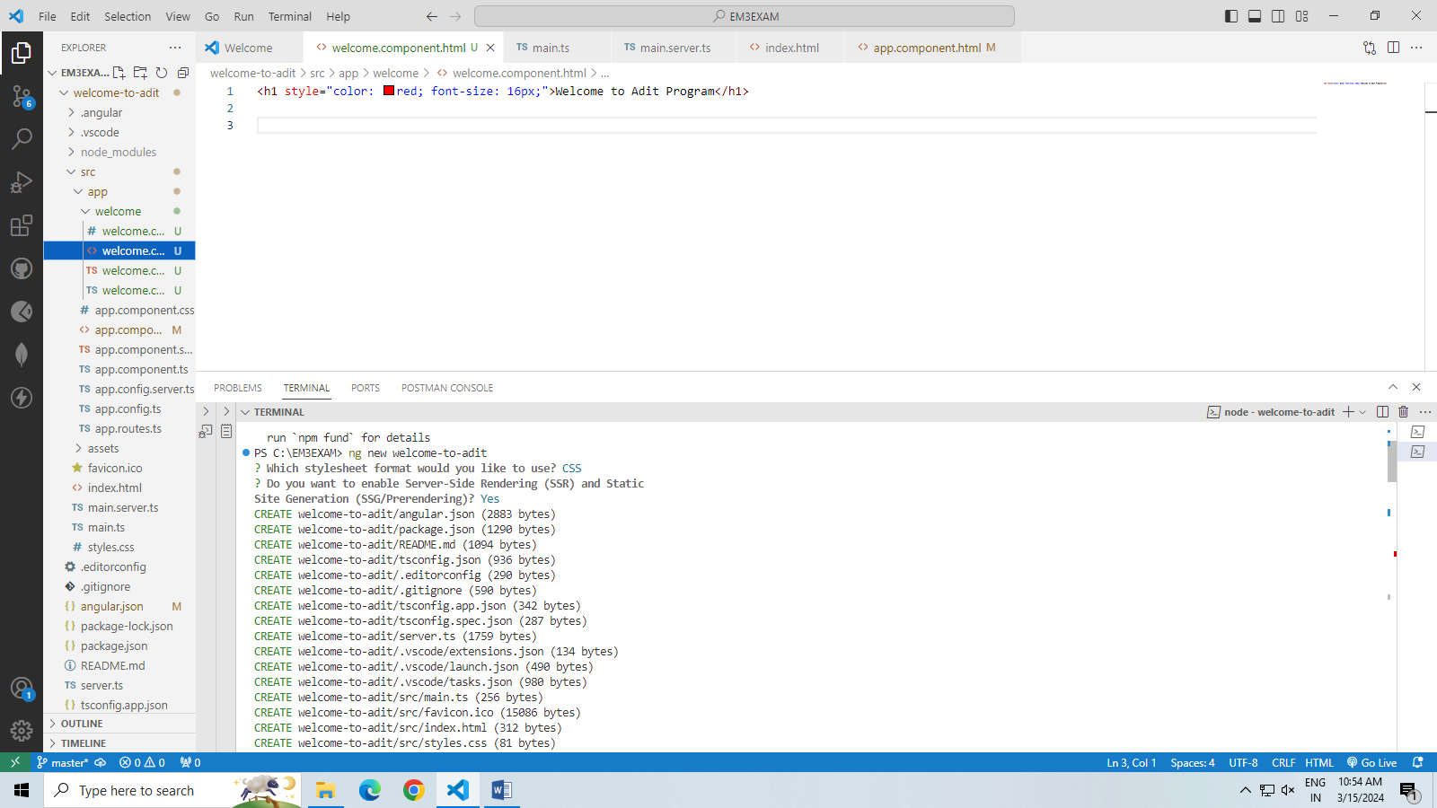

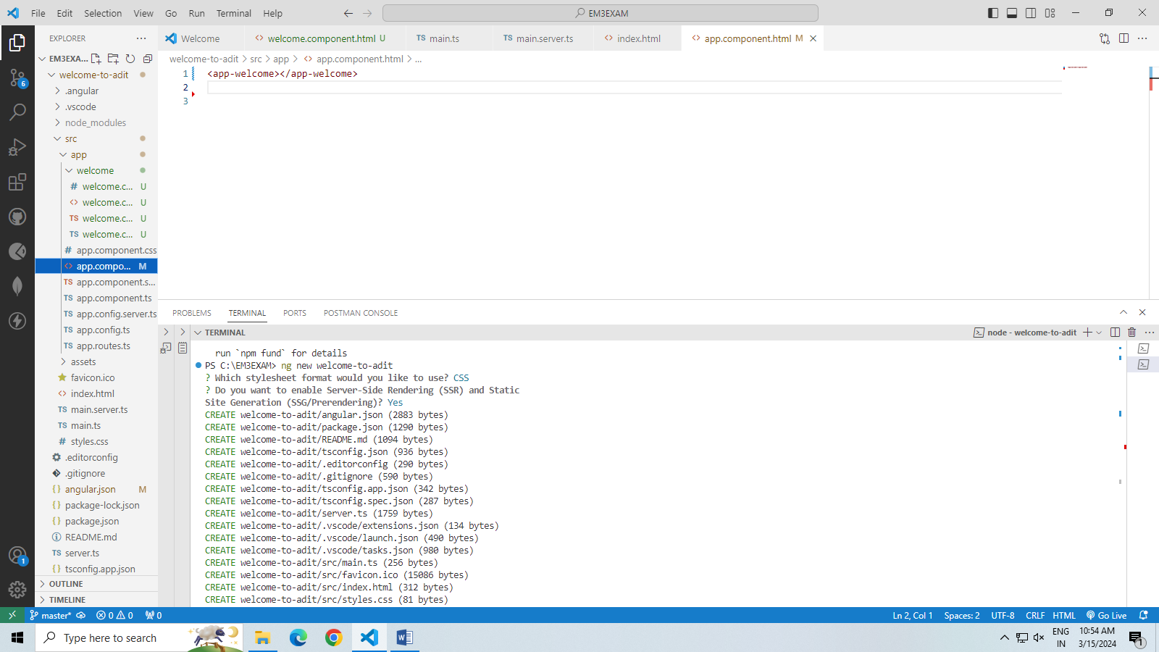

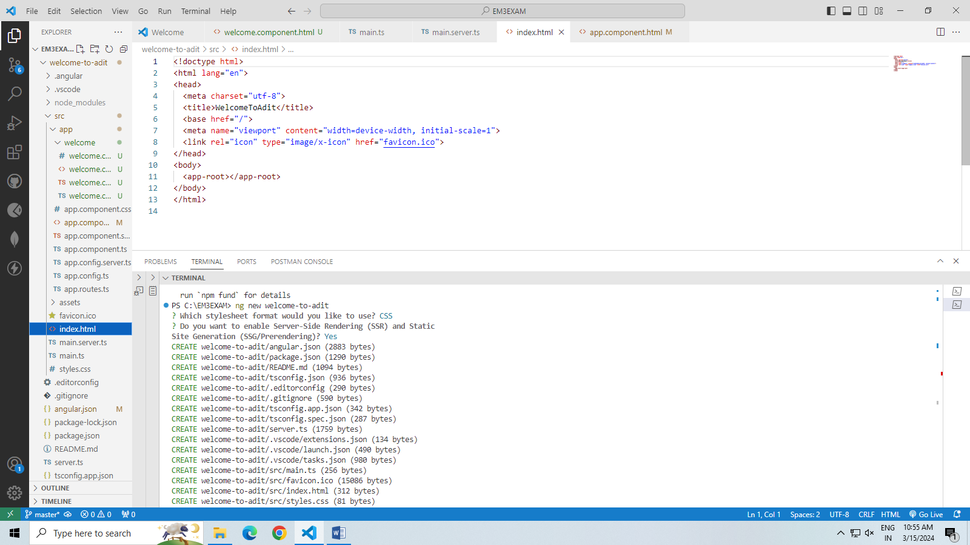

**QUESTION- 2**

**HARDWARE/SOFTWARE:**

1.COMPUTER/LAPTOP

2.WINDOWS 10/11

3.GOOGLE CROOM/ MICROSOFT EDGH

4. INTERNET

6.NODE

7.MONGODB COMPASS

**STEP-1**  node install and visual studio.

**STEP -2** CREATE a folder in c drive.

Step-3 visual studio open then folder open.

Step-4Terminal open and code are execute, and install .

npm init -y

npm install express

npm install node.js

npm install mongoosh

node index.js

Step-5 a file create index.js code are put ang page home,contact,about are created .

Step-6 then run ng serve and output is coming in browser.

